ESP1 Specifications
This has 2 views: Customer and Order
Legend: Bold primary key
Italic foreign key
Bold and Italic primary/foreign key

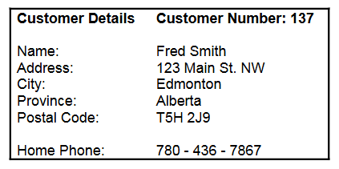
Initial Table (0NF)
- List your attributes from the view (tip use the data label names)
- Indicate repeating groups by surrounding the attributes in (…)
- Determine what the primary key is for this view (value MUST be unique)
- Optionally, name your table
Customer (CustomerNumber, Name, Address, City, Province, PostalCode, HomePhone)
1NF
- Atomize any data attributes
- Remove any existing repeating groups to their own tables
- Does a table need to have atomization or repeating groups: NO!!!!
Customer (CustomerNumber, FirstName, LastName, Address, City, Province, PostalCode, HomePhone)
2NF
- Remove Partial Dependencies to own individual tables
- Table MUST have a compound primary key to be a candidate for partial dependencies
- Does a table need to be a partial dependency candidate: NO!!!!
Customer (CustomerNumber, FirstName, LastName, Address, City, Province, PostalCode, HomePhone)
3NF
- Remove Transitive Dependencies to own individual tables
- Table MUST have a multiple non-key attributes to be a candidate for transitive dependencies
- Does a table need to be a transtive dependency candidate: NO!!!!
Customer (CustomerNumber, FirstName, LastName, Address, City, Province, PostalCode, HomePhone)

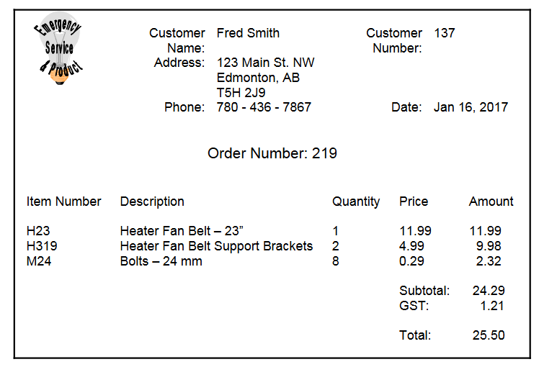
Initial Table (0NF)
- Pkey candidates: CustomerNumber, OrderNumber, ItemNumber
- Discard ItemNumber: part of the repeating group
- What is this view all about?
  - The customer?
  - The Order?
- The view is about an Order and the data needed for the order.
Order (OrderNumber, CustomerNumber, CustomerName, Address, Phone, OrderDate, (ItemNumber, Description, Quantity, Price, Amount), Subtotal, GST, Total)
1NF
Order (OrderNumber, CustomerNumber, CustomerFirstName, CustomerLastName, Address, City, Province, PostalCode, Phone, OrderDate, Subtotal, GST, Total)
OrderItems (OrderNumber, ItemNumber, Description, Quantity, Price, Amount)
2NF
- Historical data (check documentation to see if there is any mention of keeping the attribute independent)
- Example, Does Price change over time?
  - Yes
  - Do I need to save both the historical price and have a separate current price?
  - Yes, then you need to rename the attribute to unique names
  - Rename Price to OrderPrice and CurrentPrice
Order (OrderNumber, CustomerNumber, CustomerFirstName, CustomerLastName, Address, City, Province, PostalCode, Phone, OrderDate, Subtotal, GST, Total)
OrderItems (OrderNumber, ItemNumber, Quantity, OrderPrice, Amount) (associative table, usually contains the foreign key indication)
Item (ItemNumber, Description, CurrentPrice)
3NF
Order (OrderNumber, CustomerNumber, OrderDate, Subtotal, GST, Total)
OrderItems (OrderNumber, ItemNumber, Quantity, OrderPrice, Amount)
Item (ItemNumber, Description, CurrentPrice)
Customer (CustomerNumber, CustomerFirstName, CustomerLastName, Address, City, Province, PostalCode, Phone)

Merge
- This is where we take all the tables from the multiple view and create a single unique set of tables
- Examine the tables for identical primary keys (be careful about names)
- Examine attributes
  - Are the names the same, if so, record only once
  - Are the names different BUT are about the same data, if so, choose one of the names to represent the data
- The result of the merge may reduce the overall number of tables
- Why, we are combining the tables
- Do I need to have a merging of tables: NO!!!!!!
Customer (CustomerNumber, FirstName, LastName, Address, City, Province, PostalCode, HomePhone)
Order (OrderNumber, CustomerNumber, OrderDate, Subtotal, GST, Total)
OrderItems (OrderNumber, ItemNumber, Quantity, OrderPrice, Amount)
Item (ItemNumber, Description, CurrentPrice)

